What is Jira?

Jira is a tool developed to help teams for project management, bug tracking, and issue tracking. In simple terms, it is an **issue tracker**. Jira is widely used by big companies in software development and software testing. It is web-based and licensed product created by Australian Company [**Atlassian**](https://www.atlassian.com/).

**

*Atlassian Logo*

The name "Jira" is derived from the truncation of *Gojira*, the Japanese word for *Godzilla*. Here, a reference is made to the competitor *Bugzilla*.

**

*Bugzilla Logo*

When Jira was released in 2002, it was seen as an issue tracking software used by software developers. Later, this application was accepted as a **project management tool** by software companies as well as other organizations. By digitally copying your various work-based processes into what are called workflows in Jira, you can open tickets or issues and push them through various statuses in your processes, entering in relevant information along the way. We will see these elements and more in the following pages.

**Q**: What is Jira?  
**A**: Jira is a tool developed to help teams for project management, bug tracking, and issue tracking. In simple terms, it is an issue tracker. Jira is widely used by big companies in software development and software testing.

Who Uses Jira?

Jira started primarily as a tool for software development, but over the last few years, it's been adopted by customers in all sorts of industries. The areas in which Jira Software is used to organize and operate teams efficiently include financial services, retail, software, high-tech, automotive, non-profit organizations, government, life sciences, and many more.

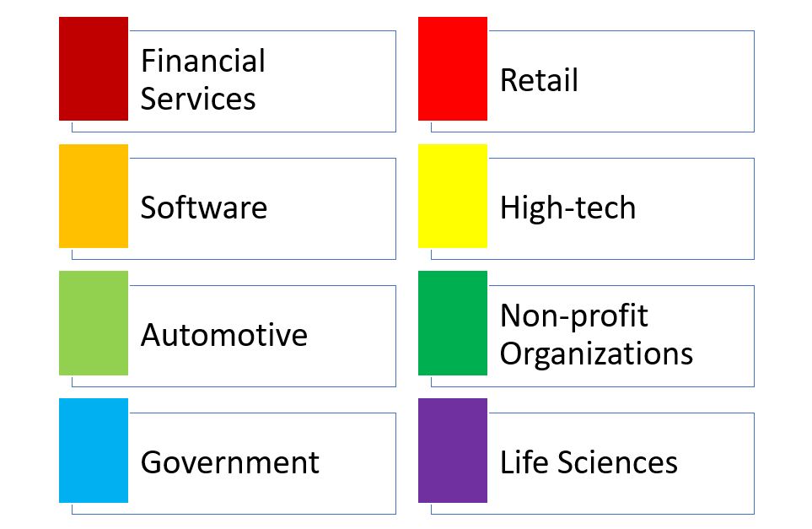

*Industries Supported by Jira Software*

Atlassian announces that Jira Software is used by more than 65,000 companies around the world for issue tracking and project management. According to the website of Atlassian, a considerable majority of Fortune 500 companies use Jira and Atlassian products. Some of the worldwide companies that use Jira at certain times for bug-tracking and project management are Samsung, Coca Cola, Domino’s, Nestle, Hitachi, Pfizer, Visa, Costco, Delta Airlines, Office Depot and so on. 

*Worldwide Companies that Use Jira at Certain Times*

You will now watch a video to discover how Starz Entertainment, creators of *Spartacus* and *Da Vinci Demons*, uses the Jira to drive its agile process.

## **Jira Products**

### Jira Family

The Atlassian product family includes many products that it has developed and operated for teams. The list of products available on the Atlassian website is given in the following picture:

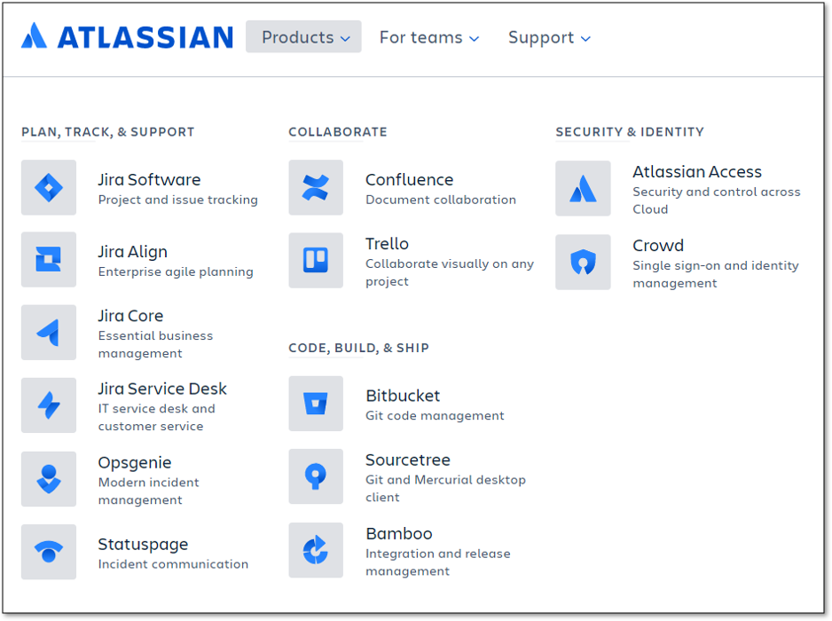

Atlassian Products

Jira is divided into four different products and the term Jira is referred to as a common platform in which all these products are created. The four products of the Jira family are:

* Jira Software
* Jira Align
* Jira Core
* Jira Service Desk

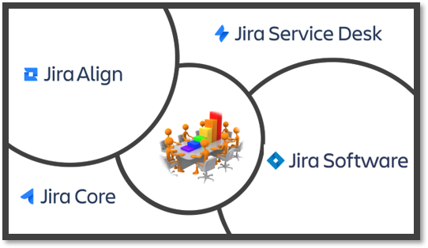

Jira Family

**💡Tips:**

* The **Jira Administrator** controls all access to Jira Applications and what users can do in Jira.

**Q**: List the Atlassian products that are members of Jira family.  
**A**: Jira is divided into four different products and the term Jira is referred to as a common platform in which all these products are created. The four products of the Jira family are: Jira Software, Jira Align, Jira Core, and Jira Service Desk.

### Jira Software

This is a software development tool **used by agile teams** (formerly known as JIRA Agile). It is very suitable for software development teams who want to use agile methodologies such as Scrum and Kanban. Jira Software is designed to plan, monitor, and release great software for each member of the software team. Jira Software aims to enable software developers to release higher quality software faster.

|  |
| --- |
| *Jira Software is a tool used by agile teams* |

Jira Software is instrumental in building and maintaining the best software on the market.

-- *DANIELE FARNEDI, TRULIA CTO*

### Jira Align

When larger corporate businesses engage in agile scaling, they often need Jira or other tools to make decisions without disturbing their agile teams. Jira Align is a member of the Jira family which allows the company leadership to monitor current developments and link them to business outcomes at an enterprise scale.



## **Jira Products**

It is developed for general-purpose project management. This is similar to the classic Jira, optimized for business teams, with all the field customizations and workflow capabilities. Jira Core keeps the teams organized by managing projects, monitoring details, and measuring performance.



|  |
| --- |
| *Jira Core is a tool used by business teams* |

Jira Core brings so many benefits to any team that does anything following a process.

-- *GEORGE LEWE, LUFTHANSA SYSTEMS*

### Jira Service Desk

Jira Service Desk is a modern IT service desk software that can run on the cloud or server. With this product, service desks can easily receive, monitor, manage and resolve the requests from customers. This tool brings a high-level order to your business, lets you view what your team is doing, and helps your agents do more.

|  |
| --- |
| *Jira Service Desk is a help desk request tracker* |

Since deploying Jira Service Desk, we’ve had our resolved tickets increase by almost 67 percent, which is a sign that our help desk team is able to actually get more work done.

-- *NICK CUNNINGHAM, IT MANAGER*

### The Scope of This Course

In this course, we will only focus on Jira Software. The majority of development teams prefer agile methods to facilitate planning and launching software easier and faster. That's why Jira software is a software development tool used by many agile teams. Besides, Jira Software has several special features that can be useful not just for software development teams, but for any business teams.

## **Jira Software Hosting Options**

### Hosting Options

Teams can use Jira Software with two hosting options: cloud and self-managed. Customers using the self-managing option can choose between server and data center. We will now briefly discuss three hosting options called cloud, server and data center.

|  |
| --- |
| Jira Hosting Options |

**Q**: Which hosting options are available for Jira Software?  
**A**: There are three hosting options available: Atlassian Cloud, Server, and Data Center (Amazon Web Services (AWS) and Microsoft Azure).

Cloud

With Jira Software Cloud, the Jira Software site is hosted and installed in the cloud for you. This hosting option is usually preferred by the teams who want to get started quickly and practically. Thus, agile teams are free from managing the technical complexity of the hosting process.

A team chooses the cloud option for a variety of reasons, as shown below:

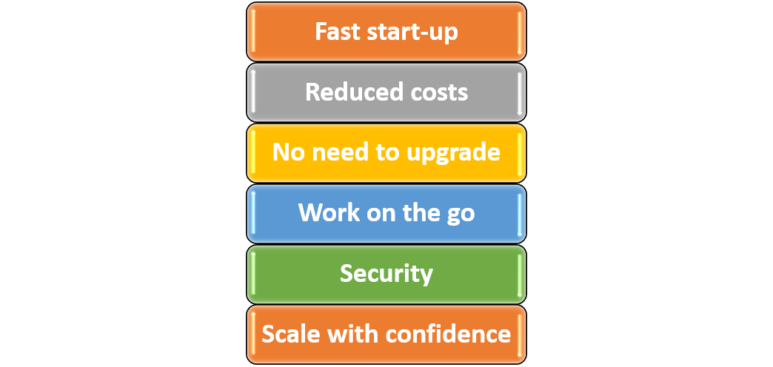

In this lesson, we will explain how to easily set up and use Jira Software through a web browser.

**💡Tips:**

* You can access your Jira Software site from mobile devices by typing the address of your site into web browsers.

**Q**: Is it possible to access JIRA cloud site via a mobile device?  
**A**: You can access your Jira Software site from mobile devices by typing the address of your site into web browsers.

### Server

Jira Software Server allows you to host Jira Software on your own hardware and customize it to suit your needs when installing. This is often the best option for teams that have experience with self-hosted applications and need to manage all the details.

Teams choose this option when they:

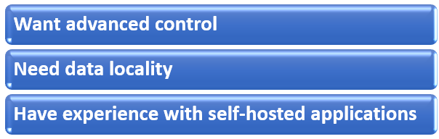

### Data Center

With this option, Jira Software can be hosted on your hardware or public cloud services such as Amazon Web Services (AWS) and Microsoft Azure. Jira Software Data Center is often the best deployment option for enterprise teams that need uninterrupted access and high performance.  
  
Teams considering the option of self-hosting adopt Data Center to:

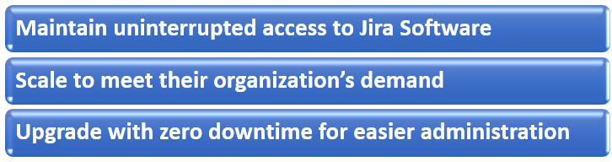

## **Setting up Jira Software Cloud**

### How to Set up Jira Software Cloud

Since Jira Software **Cloud** is a web application, you do not need to download and install it on your computer. You only need a few steps to sign up and run Jira Software Cloud.

### Step-1

Go to the Atlassian website: [**https://www.atlassian.com/**](https://www.atlassian.com/)

### Step-2

After the Atlassian website is displayed,

a. Click on the ‘Products’ menu from the top left-hand corner of the screen,

b. Select the Jira Software option.

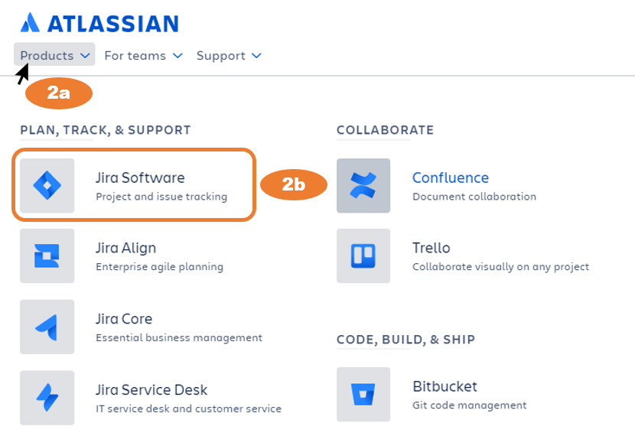

### Step-3

You will see the product page of Jira Software and you will be able to see free and paid plans according to the number of users in your team. Decide which plan is right for you. Atlassian offers Jira Software Cloud free of charge for up to 10 users with a 2GB storage capability.

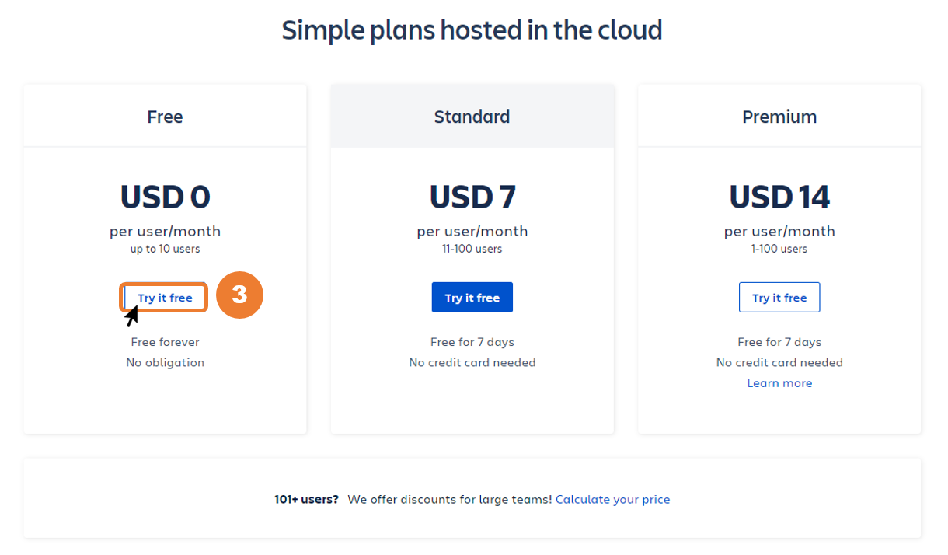

### Step-4

In order to have Jira Software Cloud, you need to create an account, as shown in the following picture. Your account will be created by following the steps below:

a. Enter your e-mail address,

b. Enter your first name and last name,

c. Enter site name you want to create in the Atlassian cloud,

d. Click "Agree and Sign up" button.

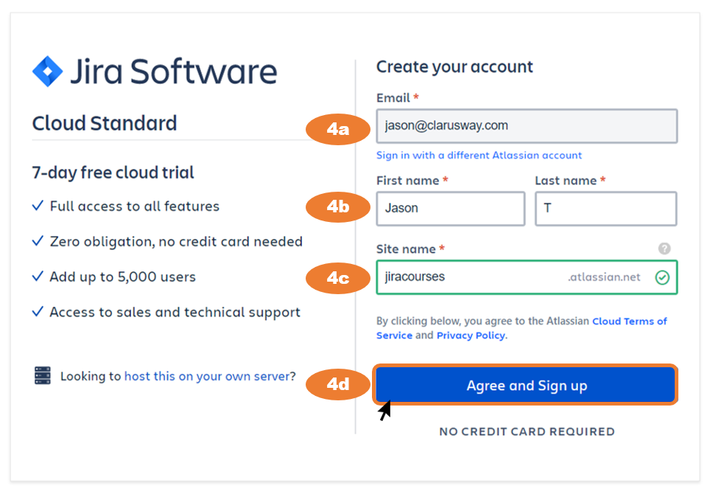

**💡Tips:**

* If you plan to host Jira Software on your own server, you can click the relevant link on this page

### Step-5

The Jira Software asks you two optional questions to personalize your experience:

* What type of team do you work in?
* Which of these best describes what you do?

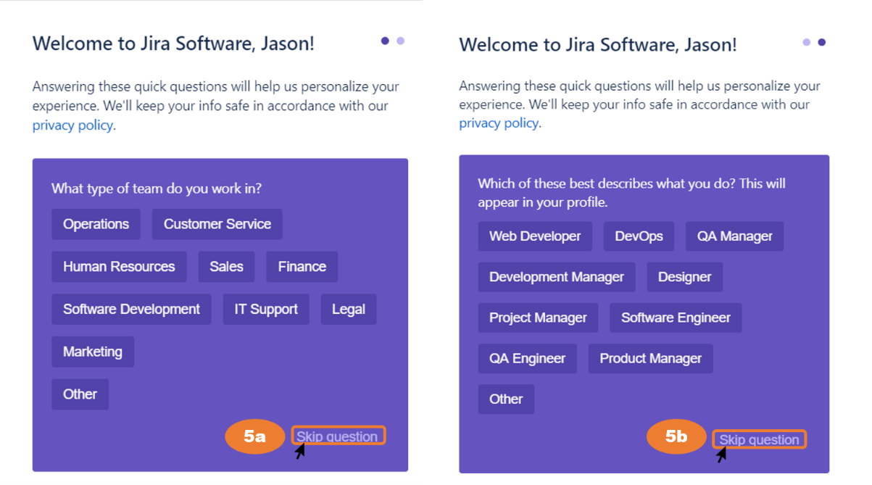

Depending on your choice, you can either answer these questions or skip this part.

### Step-6

In a few seconds, your Atlassian Cloud site will be created. Then, you will be directed to the page where you can invite your teammates to your site. You can also skip this part at this stage. 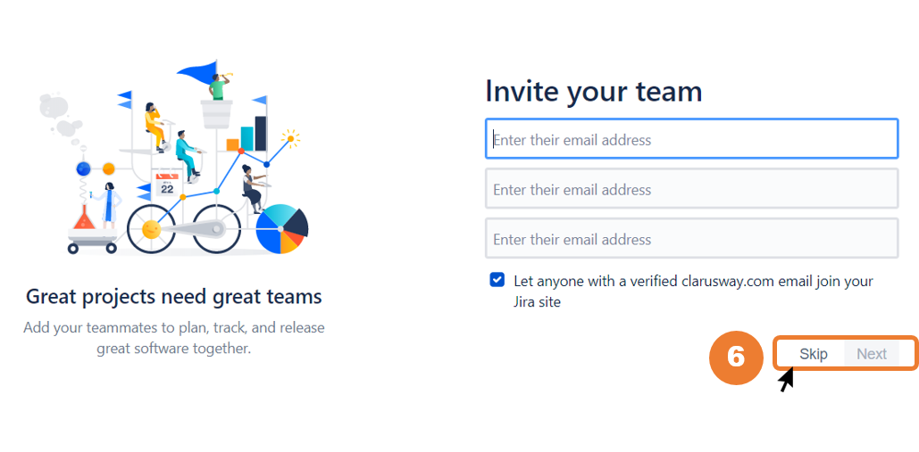

### Step-7

Then you will be directed to the "Recommend a project" page. It is your choice to fill or skip the 4 expressions that appear on your screen. You can fill these expressions and click the next button or skip this part. If you prefer to click on the Next button, you will be offered a project template in accordance with your selections.

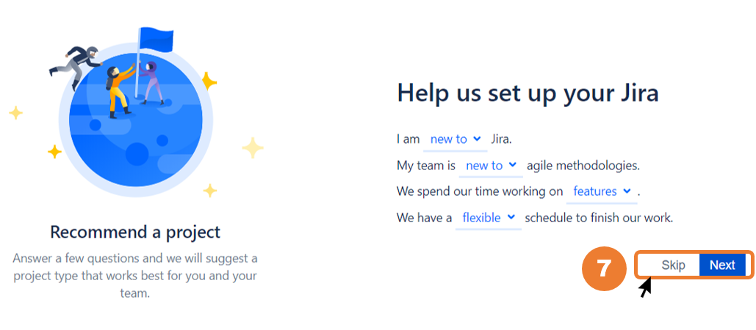

### Step-8

In this step, you will be offered suitable project templates for you. There are three classic templates in Jira Software: Scrum, Kanban, and Bug Tracking. In this course, we will use the Scrum template as we will go through scrum agile.

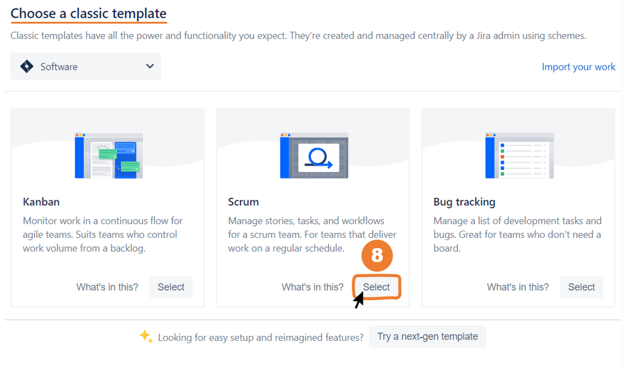

**💡Tips:**

* There are two types of boards in Jira Software: classic and next-gen.
* You can also see next-gen templates by clicking the "Try a next-gen template" at the bottom of the page.
* In general, next-gen projects are easier to administer than classic projects, but classic projects have a bit more power than next-gen projects.

### Step-9

In "Create project" section,

a. Give your project a name of your choice,

b. Designate your project key,

c. Click the "Create" button.

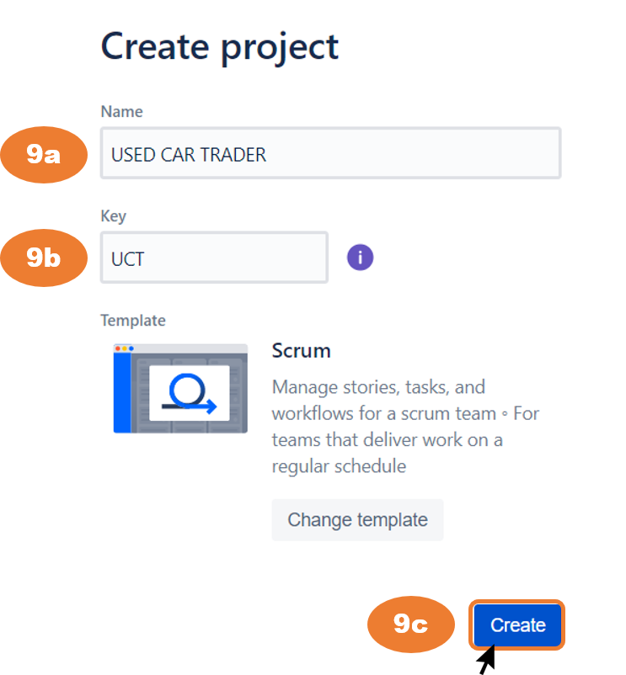

**💡Tips:**

* A project key is a unique code for your project.
* Jira Software will automatically generate a short project key in accordance with your project name.
* However, if you want to specify this auto-generated key yourself, you can change it.

**Q**: What is project key in Jira Software?  
**A**: A project key is a unique code for your project. Jira Software will automatically generate a short project key in accordance with your project name. However, if you want to specify this auto-generated key yourself, you can change it.

Finishing Setup and Navigating in JIRA Menu

**That's it, your site was created.** The login page for your site will look like the picture below. To log in to your site later, go to *https://****site_name****.atlassian.net*. The site name is the name you selected when you registered.

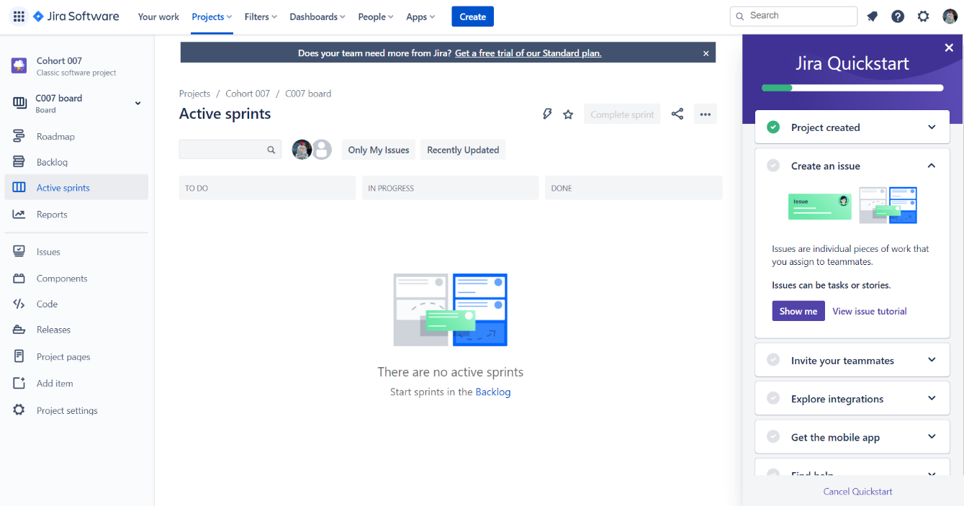

Once your site is created, you can learn about Jira Software's menu. You will now watch a short video to learn how to navigate in Jira Software Cloud.